Tour name: 3-Day Tour in Turkmenistan
Tour description: Discover the essence of Turkmenistan on this immersive 3-day journey through its striking capital, desert wonders, and cultural heritage. From the white-marble grandeur of Ashgabat to the burning Darvaza Gas Crater, this itinerary offers a rich combination of history, nature, and authentic local character.
Starting Point: Ashgabat International Airport
Ending Point: Ashgabat International Airport
Please note: The starting and ending points of the itinerary may be adjusted depending on the client’s request, logistics, and tour format.
Group Size: 3+
Duration: 3 Days
Price: From 540 USD per person
Pricing note: The tour price depends on the number of participants. The more people join the tour, the lower the price per person will be.
Day 1 | Arrival in Ashgabat – City Tour – Old Nisa  Upon arrival in Ashgabat, you will be met by your guide and transferred to the city. After check-in at the hotel, you will begin your introduction to the capital of Turkmenistan — one of the most unusual cities in Central Asia, famous for its monumental architecture and its remarkable white-marble cityscape.  During the city tour, you will visit some of Ashgabat’s most iconic landmarks, including the Independence Monument, the Neutrality Monument, the Wedding Palace, the Alem Ferris Wheel, and the Memorial Complex. Afterward, you will continue to Old Nisa, the ancient Parthian fortress and a UNESCO World Heritage Site, considered one of the most important historical monuments of the Parthian Empire.  In the evening, free time for rest.  Overnight at the hotel in Ashgabat.  Distance of the day: ~70–90 km
Day 2 | Ashgabat – Karakum Desert – Darvaza Gas Crater  After breakfast, depart from Ashgabat and drive through the vast landscapes of the Karakum Desert toward one of Turkmenistan’s most famous attractions — the Darvaza Gas Crater, widely known as the “Door to Hell.”  This journey offers a unique impression of Turkmenistan’s remote desert scenery and the atmosphere of travel through the heart of the country. Upon arrival, you will explore the crater and its surroundings. The most spectacular time to visit is in the evening, when the flames become especially dramatic against the dark desert backdrop.  Dinner will be served near the crater.  Overnight in a yurt camp or tent camp near Darvaza.  Distance of the day: ~280 km
Day 3 | Darvaza – Ashgabat  In the morning, you will have another opportunity to see the crater in daylight and take photos in a completely different atmosphere from the night before. After breakfast, depart for the drive back to Ashgabat.  Upon arrival in the capital, depending on your flight time, an additional short walk in the city, a visit to the local bazaar, or some souvenir shopping can be arranged. After that, transfer to the airport.  End of the tour in Ashgabat.  Distance of the day: ~280 km

Tour Price includes:
Meet and greet at Ashgabat International Airport with local English-speaking guide
• All transfers and transportation throughout the program
• Accommodation in hotels in Ashgabat
• 1 night desert camp accommodation near Darvaza
• 3 breakfasts
• 1 barbecue dinner at Darvaza
• Sightseeing tours and excursions as per itinerary
• Entrance fees to all sites mentioned in the program
• Visits to Independence Monument, Neutrality Monument, Alem Ferris Wheel, Memorial Complex
• Visit to the National Museum of Turkmenistan
• Excursion to Old Nisa UNESCO World Heritage Site
• Darvaza Gas Crater excursion
• Bottled water during the tour
• Invitation letter

Tour Price NOT includes:
• International flights
• Lunches and dinners, except where specified in the program
• Turkmenistan tourist visa fee and migration charges
• Personal expenses
• Tips for guide and driver
• Optional activities not mentioned in the itinerary
• Hotel early check-in or late check-out, unless specified
• Charges for additional hotel services
• Travel insurance

Some photos from tour:
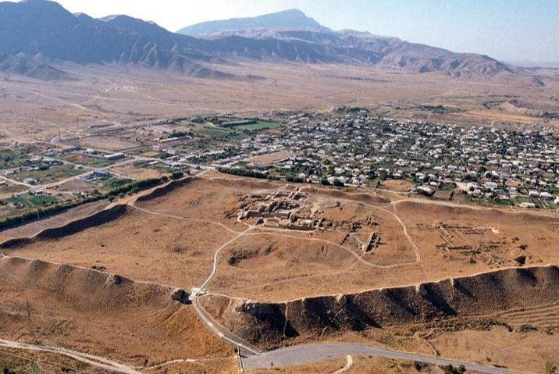
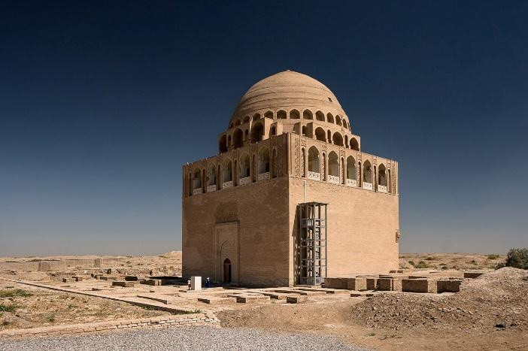
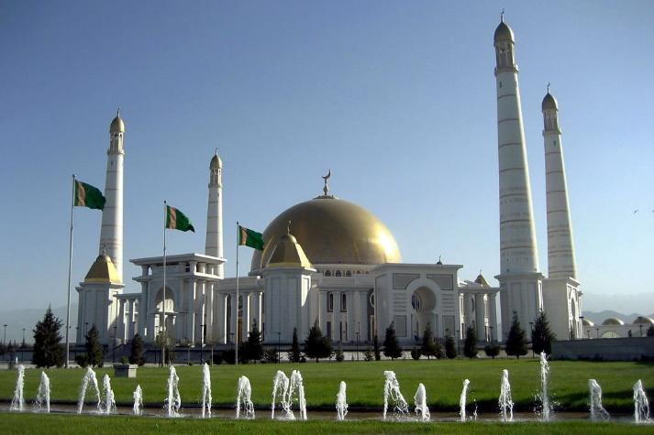

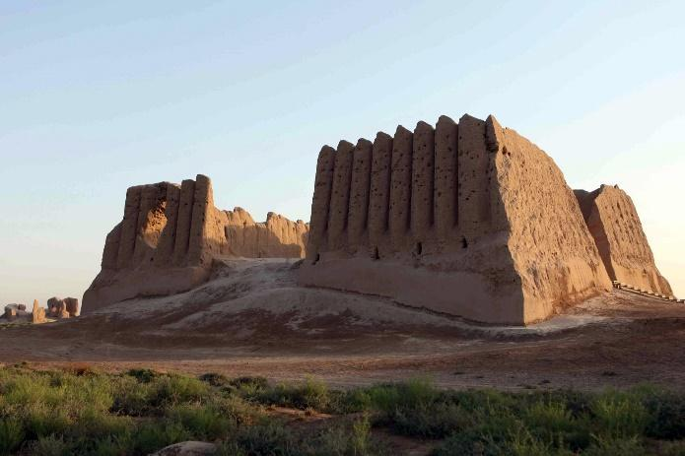

Notes
• The price is based on a minimum group size of 3 participants.
• The tour can also be organized starting from Ashgabat, Farap, or Shavat border upon request.
• The itinerary may be adjusted depending on flight schedule, weather conditions, and road conditions.

